AGENDA FOR NANOSAFETY CLUSTER MEETING
Time: Friday, September 20th, 2013; 8:30 till 16:30
Venue Address: University of Birmingham, R27 Biosciences building, Lecture theather no. 301 3rd floor, Edgbaston, Birmingham, B15 2TT
Add your details to confirm your attendance to the Google doc link below:
https://docs.google.com/spreadsheet/ccc?key=0AmP_8UY8P9AMdHFEbGhIbXBkNXFKMFkxaHFRYlNWUmc&usp=sharing
Expected Outcomes:
- Short document on strategies for WG lead projets
- Short reports/minutes on WG breakout sessions & WG plans for activity for next 12 months provided during the plenary session of the NSC lead by confirmed WG chairs and Secretaries
- Minutes from the Plenary Sessions.
- All documents will be posted on NSC website
- Organisation of EU-US workshop and Antalya event(s)
Time | Length (mins) | Venue | Title | Speaker
8:30 - 9:00 | 30 | WG4,  Biosciences | Coffee and Registration (Collect Internet password)
9:00 -9:05 | 5 | 301, 3rd floor Biosciences | Plenary Session | Dr. Kai Savolainen
9:05 – 9:20 | 15 |  | Introduction of new project coordinators (e.g. Egon Willighagen- ENano Mapper); Antonio Marcomini, SUN; Robert Rallo (MODERN)who will lead NSC WG activities | Dr. Iseult Lynch
9:20 – 9:35 | 15 |  | Launch of the systems Biology Working Group | Dr. Bengt Fadeel
9:35- 10:00 | 25 |  | Planning cluster activities for next 12 months  Strategies for Large projects to provide leadership for WG activity | Dr. Kai Savolainen
10:00 -10:15 | 15 |  | Organisation of the EU-US workshop next Dec,2-3 and organisation of the Antalaya event(s) at Nanotox 2014 -April | Dr. George Katalagarianakis  Dr. Bengt Fadeel
10:15–10:45 | 30 | Room WG4 | Coffee Break
10:45-13:00 | 2hrs 15 mins | Meeting rooms –Geography (Breakout rooms WG wise, information provided on the day) | Working Group Breakout sessions of all WGs that are present, coordinated and prepared in advance by appointed chairs
13:00-14:00 | 1 hr | Room WG4 | LUNCH
14:00- 15:30 | 1hr 30 mins | 301 meeting room | Plenary session for feedback from WG sessions-summary of next steps
14:00-14:08 | 5+3 |  | WG1 Material progress | Request to Dr. Rudolf Reuther (Nano Valid) to appoint chair (Sergio Moya?)
14:08-14:16 | 5+3 |  | WG2 Hazard progress | Dr. Flemming Cassee (Nano MILE)
14:16-14:24 | 5+3 |  | WG3 Exposure progress | Dr. Derk Brouwer (Nanosolutions)
14:24-14:32 | 5+3 |  | WG4 Database progress | Dr. Egon Willighagen (eNanoMapper)?to be appointed by Coordinator
14:32-14:40 | 5+3 |  | WG5 Risk progress | Dr. Lang Tran (Marina)
14:48 – 14:56 | 5+3 |  | WG6 Modelling progress | Dr. Robert Rallo (Modern)
14:56 – 15:04 | 5+3 |  | WG7 Dissemination + Standardisation progress | Dr. Iseult Lynch (QualityNano) Dr. Olivier Salvi (NanoStair)
15:04-15:12 | 5+3 |  | WG 8 Systems Biology | Dr. Bengt Fadeel (Nanosolutions)
15:12 – 15:25 | 13 |  | Discussion, next steps | Dr. Iseult Lynch  Dr. Kai Savolainen
15:25 – 15:30 | 5 |  | Closing session | Dr. Kai Savolainen
15:30 -14:30 | 30 | Room WG4 | Coffee

Venue Detail:
University of Birmingham, In Biosciences building (R27 on map below). Room no. 301, 3rd floor, Edgbaston, Birmingham B15 2TT.
Coffee and Lunch served at WG4.
Breakout session meeting rooms in Geography building (R26). Below is the building view for directions.
Within Building Direction
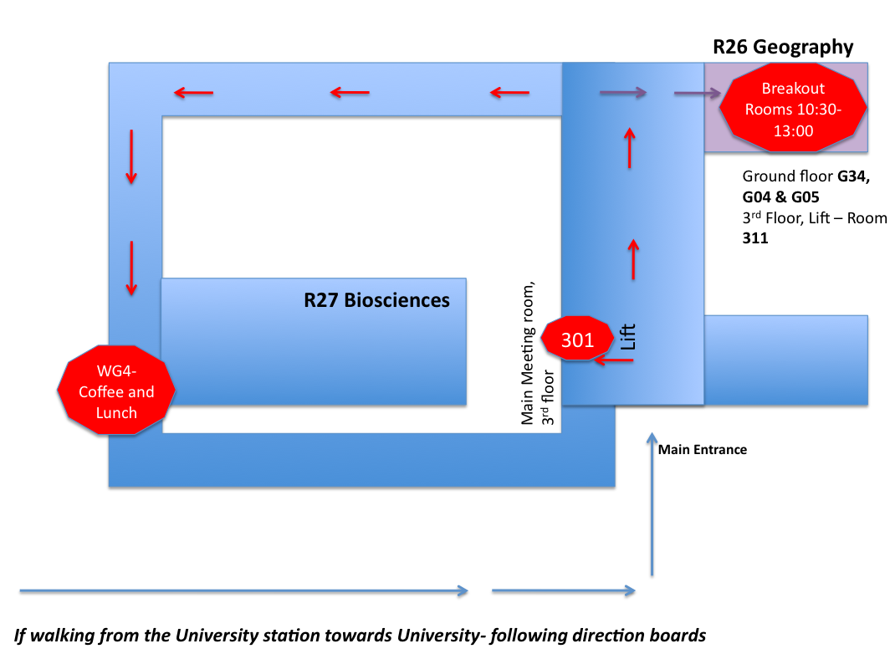
Campus Map view
